Project Design Phase
Problem – Solution Fit Template

Date | 15 February 2026
Team ID | LTVIP2026TMIDS75194
Project Name | Deep Learning Fundus Image Analysis for Early Detection of Diabetic Retinopathy
Maximum Marks | 2 Marks

Problem – Solution Fit Template:
Problem–Solution Fit refers to identifying a real-world problem faced by users and ensuring that the proposed solution effectively resolves it. In this project, the focus is on addressing the challenge of early detection of diabetic retinopathy, a serious eye disease that can lead to permanent vision loss if not diagnosed in time. Traditional screening methods require specialized ophthalmologists, costly equipment, and manual examination of retinal images, which makes the process time-consuming, expensive, and inaccessible to many patients, especially those in rural or underserved areas. As a result, many diabetic patients are diagnosed only in advanced stages of the disease. The proposed solution is a deep learning–based automated system that analyzes retinal fundus images using convolutional neural networks to detect early signs of diabetic retinopathy. This system enables quick, accurate, and scalable screening by automatically identifying abnormalities and generating results, thereby reducing dependency on manual diagnosis and allowing healthcare professionals to focus on treatment decisions. By improving accessibility, reducing diagnostic time, and supporting large-scale screening programs, the solution effectively fits the needs of patients, doctors, and healthcare organizations, ultimately enhancing early detection rates and helping prevent vision loss.

Template:
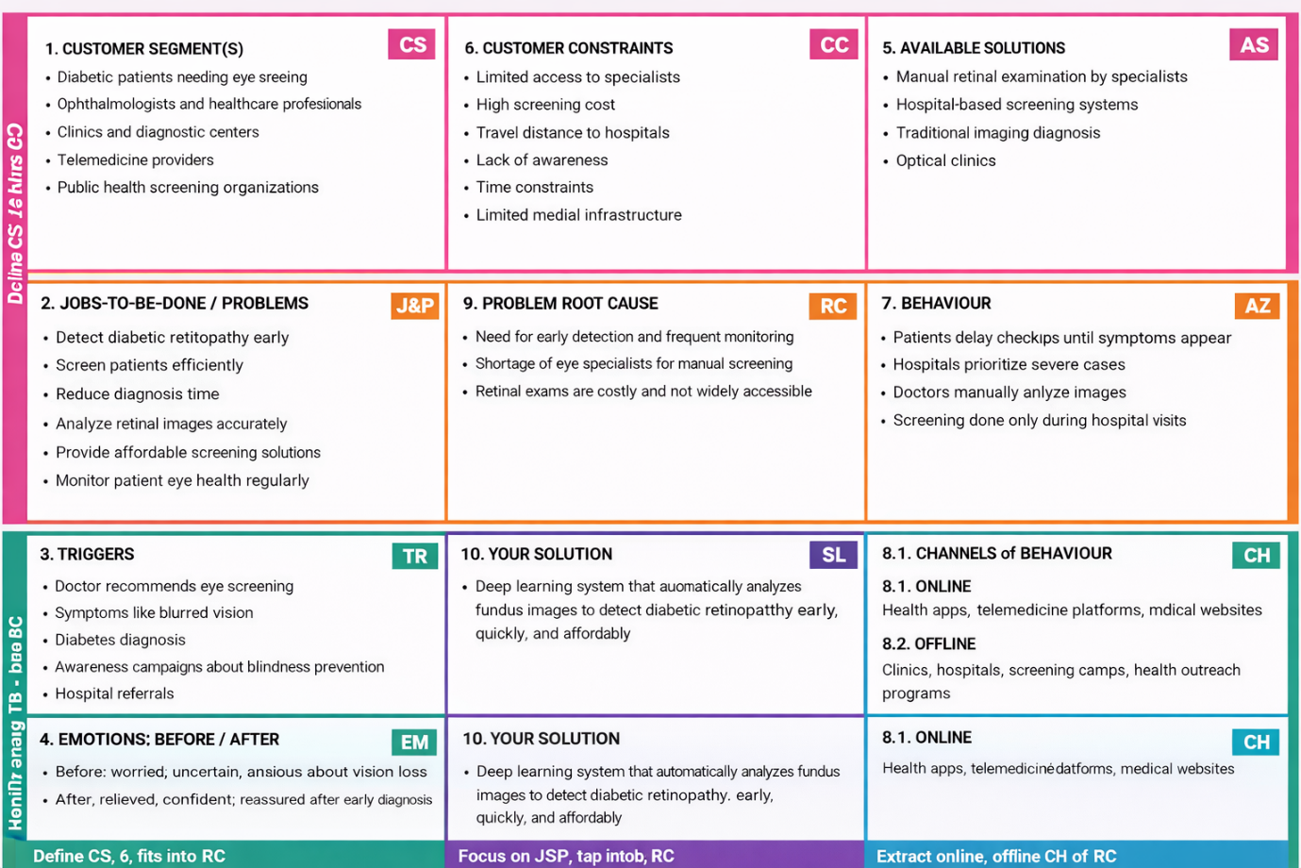
References:
- https://www.ideahackers.network/problem-solution-fit-canvas/
- https://medium.com/@epicantus/problem-solution-fit-canvas-aa3dd59cb4fe

